CSIT314 Software Development Methodologies - Group Project

Sprint 5 - US37: View IDP view statistics
Interior Design Platform - Interior Designer
All diagrams were drawn in draw.io. Open "US37 View IDP view statistics.drawio" in this folder to edit them - each diagram is its own page in that file. The exported images are in the "diagrams" folder.

Assumptions
- The system is the Interior Design Platform from the project specification. Sprint 5 covers the Interior Designer's IDP statistics stories (view statistics US37 and save statistics US38) and the Platform Manager's daily, weekly and monthly category report stories (US46 - US48).
- We follow B-C-E: the actor only talks to the boundary (page), the boundary only talks to the controller, and the controller works with the entity classes. There is one controller per use case.
- The boundary checks all the input (required fields, lengths, formats, e.g. not suspending your own profile) and trims spaces, then passes an entity object on. The controller just calls the entity and returns the result. The entity checks for duplicates and the database state (e.g. name already used, only Active rows are changed), then saves. In US37 there is no typed input: the page takes designerId from the session, the controller just calls the entity, and the entity only returns the designer's own Active IDPs with their views.
- An IDP is an interior design project of the designer, current (US20 - US24) or past (US25 - US29). IDPAnalytics is the entity for the IDP statistics and reports (US37, US38, US46 - US48): one IDPAnalytics object is one row of the statistics table (idpId, title, projectType, categoryName and views or saves).
- Logged in as an Interior Designer (UC13) is the precondition. designerLoginRequired in app.py only sends someone with no session to /designer/login; the use case doesn't check the designer again (no InteriorDesignerLoginController).
- Views are recorded by UC32 View IDP (IDP.viewIDP): each time a customer opens an IDP, one row is added to the idp_view table (the page a customer gets back to after a US33 Save is not counted). US37 only counts these rows; it never adds a view.
- The table lists every one of the designer's Active IDPs (current and past) with its category, type and number of views - 0 if no customer has opened it - most viewed first (ties by title). Deleted (Suspended) IDPs and other designers' IDPs are not shown.
- No Active IDPs is a normal page with MSG_NO_IDPS "You don't have any active IDPs yet, so there are no views to show" instead of the table.
- Viewing the statistics is read-only. The Saves tab on the same page is US38.

1. User story
Story ID | US37
User story | As an interior designer, I want to see how many views each of my IDPs has so that I can tell which IDPs get the most attention.
Actor | Interior Designer
Priority | Medium
Story points (estimate) | 2
Acceptance criteria | 1. Given I am logged in as an interior designer, when I click "IDP Statistics" (side menu) or "View IDP statistics" (dashboard), then I see the Views tab with a table of my own Active IDPs - IDP, Category, Type and Views - most viewed first.  2. Given one of my IDPs has never been opened by a customer, then it is still listed with 0 views.  3. Given a customer opens one of my IDPs (UC32), when I open the Views tab again, then its number of views has gone up by one.  4. Given I have no Active IDPs, then I see "You don't have any active IDPs yet, so there are no views to show" and no table.  5. Deleted IDPs and other designers' IDPs are never shown, and opening the statistics changes nothing.
Tasks | #263 Draw Use Case Diagram and Write Use Case Description  #268 Design Wireframe  #273 Write and Execute Test Cases  #278 Draw BCE and Sequence Class Diagram  #283 Develop the IDP statistics page to retrieve and display the number of views received by each of the designer's projects.

2. Use case diagram
The user story becomes one use case, UC37 View IDP view statistics. The Interior Designer is the only actor. The statistics table and the "no IDPs" message are flows of this use case. The views it counts are recorded by UC32 View IDP.
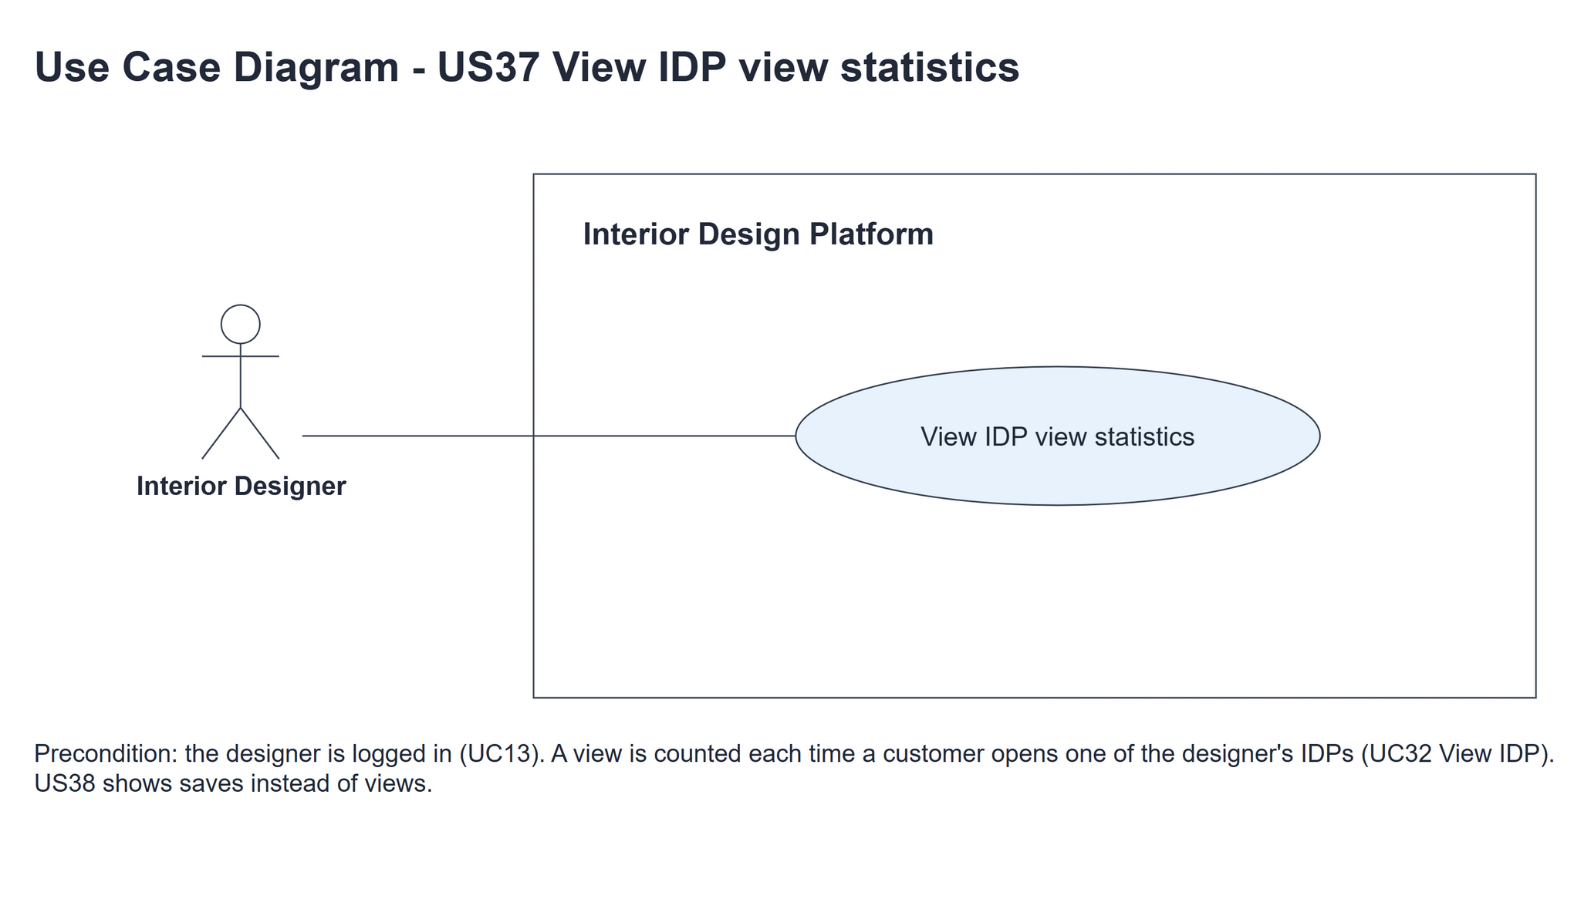
Figure 1: Use case diagram for US37 View IDP view statistics

3. Use case description
Use case | UC37 View IDP view statistics
Actor | Interior Designer
Brief description | The Interior Designer sees how many times customers have viewed each of their Active IDPs, most viewed first.
User story | US37: As an interior designer, I want to see how many views each of my IDPs has so that I can tell which IDPs get the most attention.
Preconditions | Logged in as an Interior Designer (UC13). designerLoginRequired in app.py only sends someone with no session to /designer/login.
Trigger | The Interior Designer clicks "IDP Statistics" in the side menu, "View IDP statistics" on the dashboard, or the "Views" tab.
Basic flow | 1. The Interior Designer clicks "IDP Statistics" (the Views tab opens).  2. The system gets the designer's Active IDPs, each with its number of views (0 if never viewed), most viewed first.  3. The system shows the table - IDP, Category, Type and Views - with the hint "A view is counted each time a customer opens the IDP."
Alternative flows | 2a. The designer has no Active IDPs: the system shows "You don't have any active IDPs yet, so there are no views to show" and no table. The use case ends.
Postconditions | Nothing is changed - no IDP and no view is added.

4. Wireframes
The wireframes were drawn in draw.io from the real page (templates/idpStatistics.html in the designer layout). They are low-fidelity: they show the layout and the flow, not the final colours. The orange numbers match the notes under each screen.

4a - Statistics table
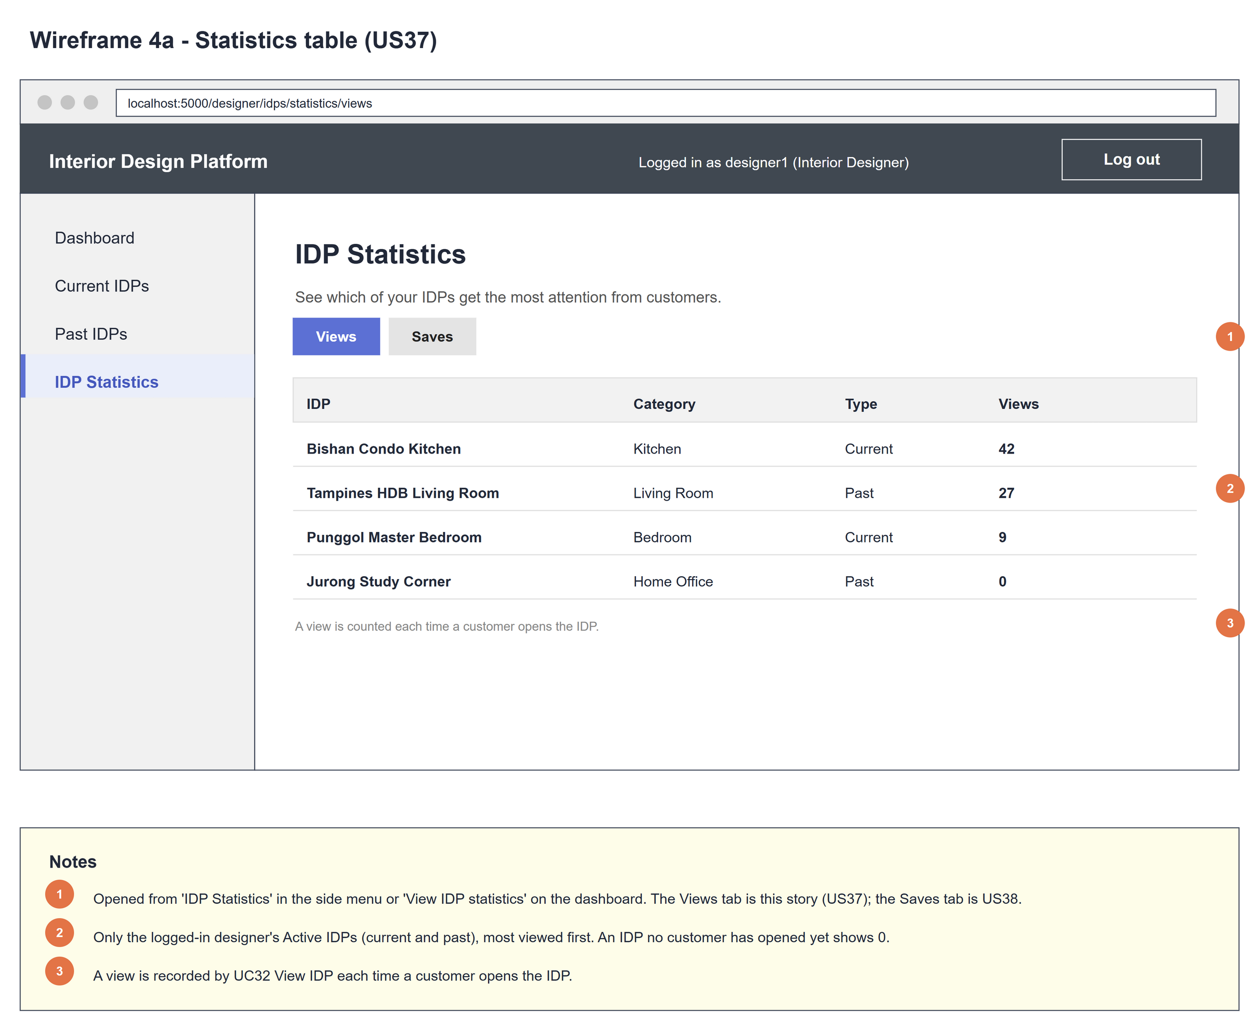
Figure 2: Wireframe 4a - Statistics table (US37)

4b - No IDPs yet
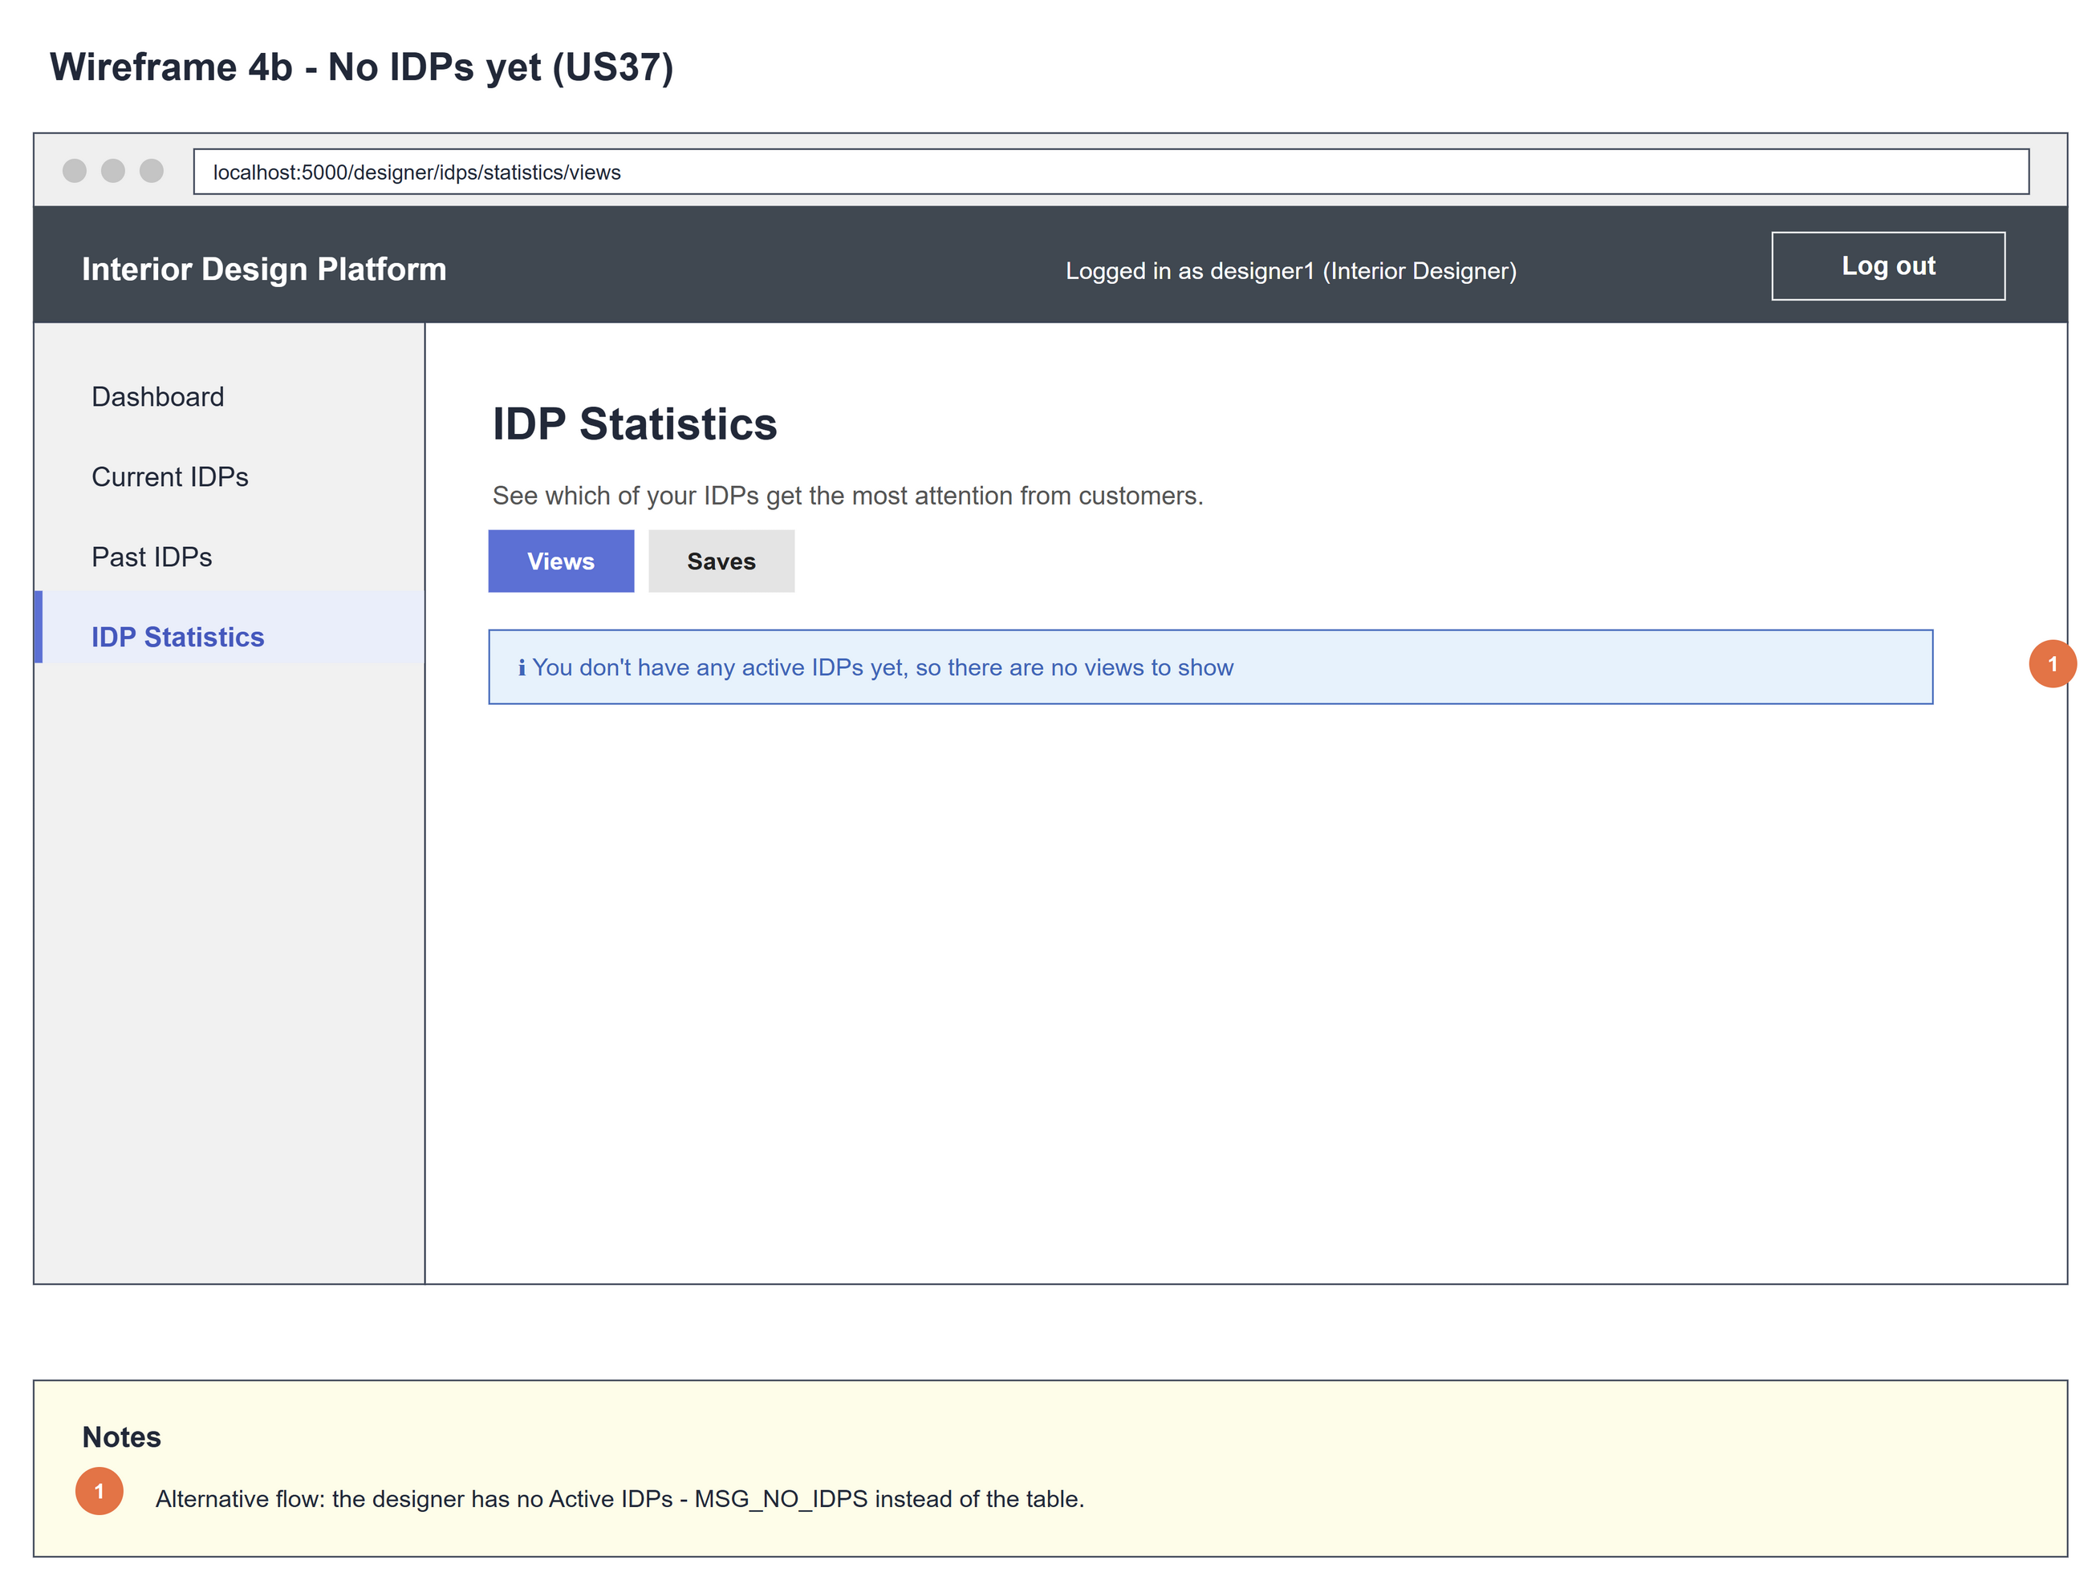
Figure 3: Wireframe 4b - No IDPs yet (US37)

5. B-C-E class diagram
The solid line means the boundary calls the controller. The dashed line means the controller uses the entity. Only the operations needed for this use case are shown. The IDPAnalytics box lists all its attributes (the same box is in US37, US38 and US46 - US48) but only the US37 method.
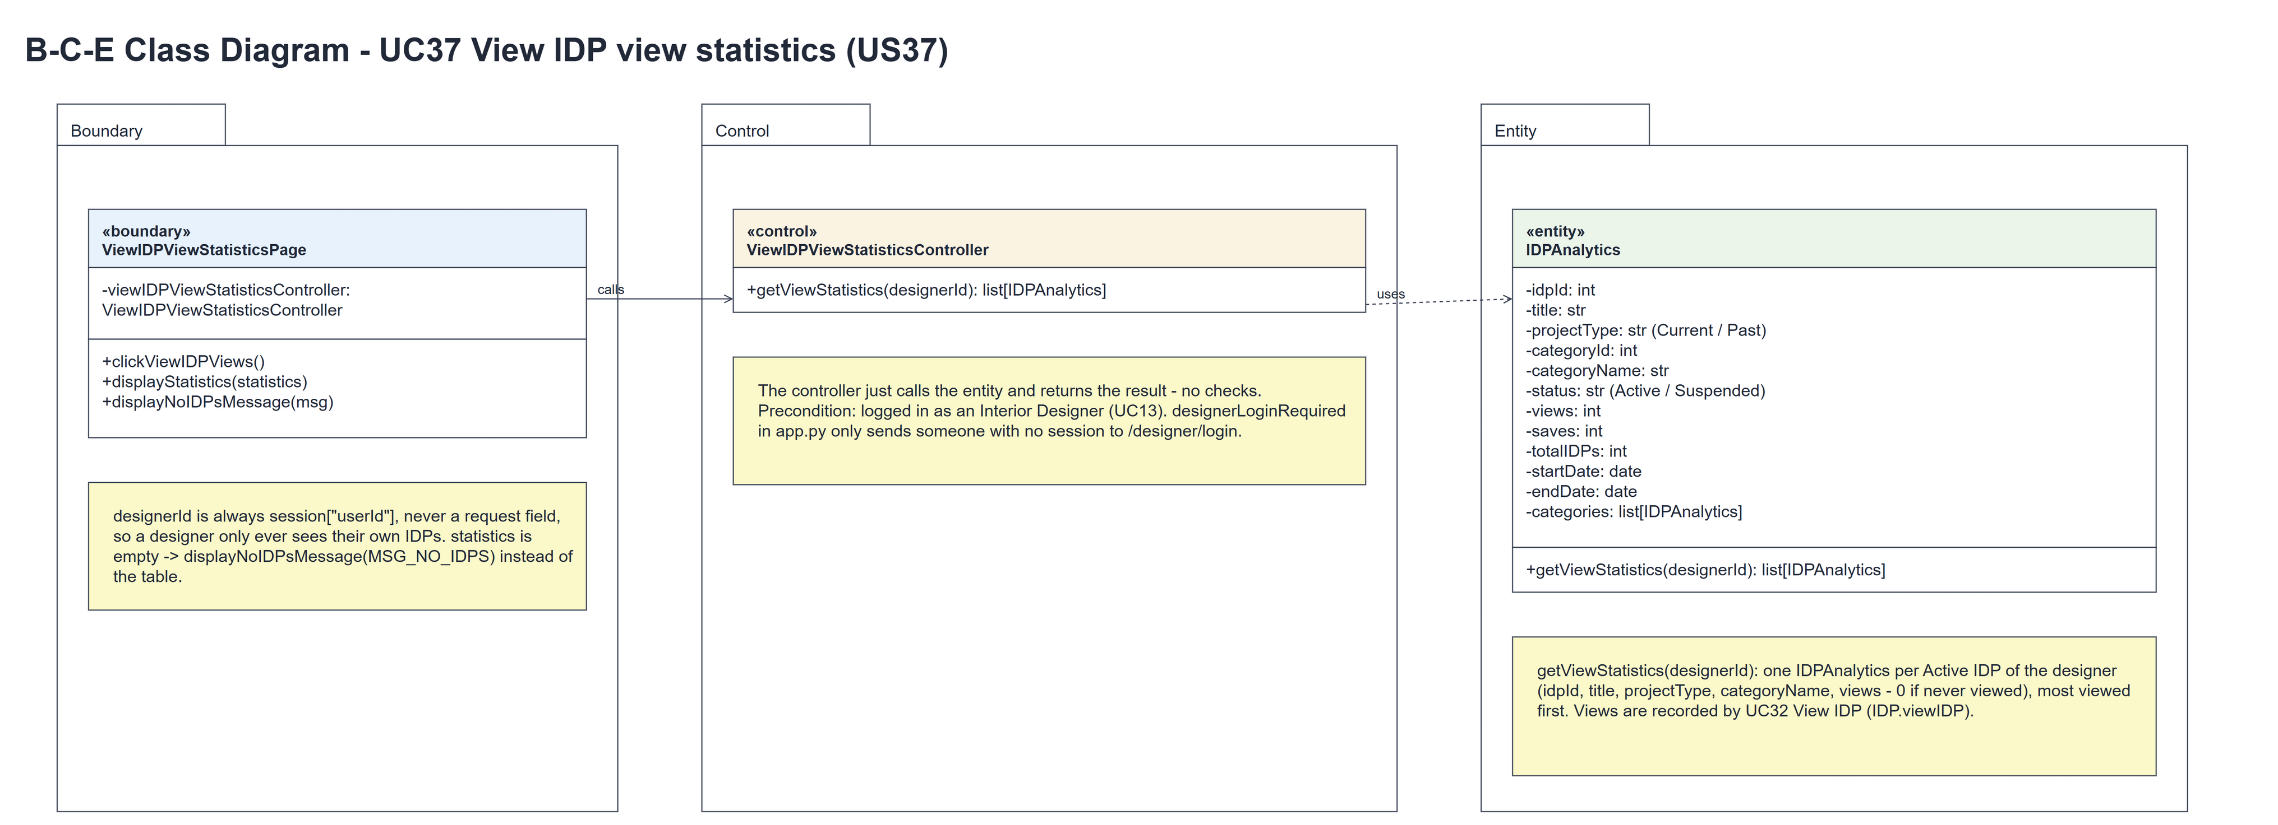
Figure 4: B-C-E class diagram for US37 View IDP view statistics
Layer | Class | What it does
Boundary | ViewIDPViewStatisticsPage | The Views tab of the IDP Statistics page. clickViewIDPViews() calls getViewStatistics(designerId) with designerId = session userId. If statistics is empty it shows displayNoIDPsMessage(MSG_NO_IDPS), otherwise displayStatistics(statistics) (the table, most viewed first).
Control | ViewIDPViewStatisticsController | Controller for UC37. getViewStatistics(designerId) just calls the entity and returns its list[IDPAnalytics] unchanged - no checks.
Entity | IDPAnalytics | The only entity. getViewStatistics(designerId) returns one IDPAnalytics per Active IDP of the designer (idpId, title, projectType, categoryName, views - 0 if never viewed), most viewed first. Views are recorded by UC32 View IDP (IDP.viewIDP).

6. Sequence diagram
The sequence diagram follows UC37. Clicking "IDP Statistics" (clickViewIDPViews()) calls getViewStatistics(designerId) with designerId = session userId; the controller makes one call to IDPAnalytics.getViewStatistics(designerId) and returns statistics unchanged (steps 1-5, basic flow 1-2). The alt then shows displayNoIDPsMessage(MSG_NO_IDPS) when statistics is empty (steps 6-7, alternative flow 2a, wireframe 4b) or displayStatistics(statistics) when it is not empty (steps 8-9, basic flow 3, wireframe 4a). There is no typed input, so there is no input check. Views are recorded by UC32 View IDP (IDP.viewIDP), not by this use case.
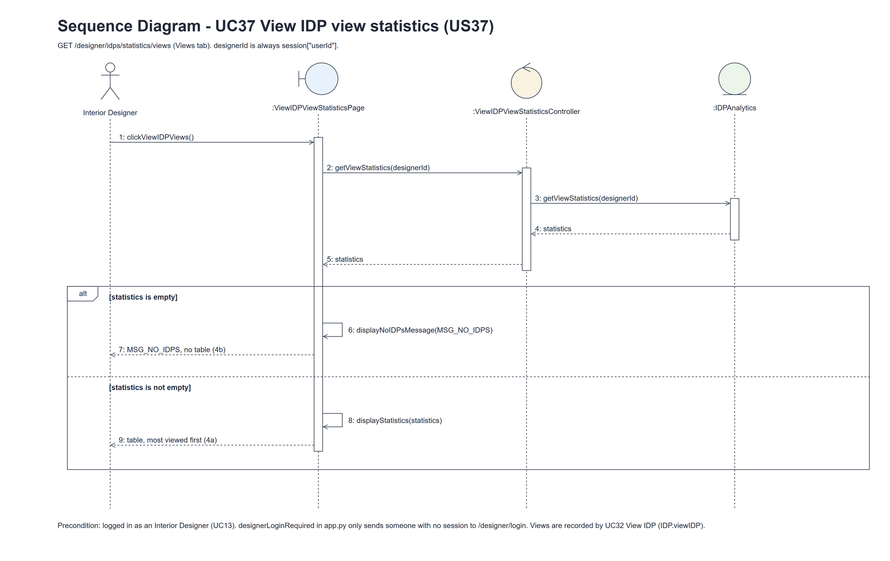
Figure 5: Sequence diagram for UC37 View IDP view statistics

7. Test cases
Test data used below (the same as tests/test_us37_viewIDPViewStatistics.py): designer accounts designer37 (A) and designer37b (B) / Design@123, made with UC8, and the customer cust001 / Cust@123. IDP category Kitchen (Active). A owns the Active IDPs "Modern Kitchen" (Current) and "Old Kitchen" (Past) and a deleted (Suspended) IDP "Deleted Kitchen"; B owns "Someone Else's Kitchen". A view is one idp_view row, added when a customer opens the IDP (UC32).

7a. System test cases (black box)
Equivalence partitioning and boundary value analysis were used to pick the test data. The team runs these by hand: fill in "Actual result" and "Pass/Fail" after running each test.
Test ID | Scenario | Prerequisites | Test steps | Test data | Expected result | Actual result | Pass / Fail
TC37.1 | View my view statistics | Logged in as A. cust001 has opened Modern Kitchen twice. | 1. Click "IDP Statistics" | A's and B's IDPs above | Views tab: Modern Kitchen (2), then Old Kitchen (0), with category and type - not the deleted or B's IDP. Hint "A view is counted each time a customer opens the IDP."
TC37.2 | A customer view is counted | TC37.1 done. | 1. Log in as cust001 and open Old Kitchen 3 times (UC32)  2. Log in as A and open the Views tab | - | Old Kitchen (3) is now above Modern Kitchen (2).
TC37.3 | IDP never viewed | Logged in as A. Nobody has opened Old Kitchen. | 1. Open the Views tab | - | Old Kitchen is listed with 0 views.
TC37.4 | No Active IDPs | Logged in as a designer whose only IDP is deleted (or who has none). | 1. Click "IDP Statistics" | - | "You don't have any active IDPs yet, so there are no views to show"; no table.
TC37.5 | Views and Saves tabs | Logged in as A. | 1. Open the Views tab  2. Click "Saves" | - | The Views tab is highlighted; "Saves" opens the US38 save statistics.
TC37.6 | Links to the statistics | Logged in as A. | 1. Open the dashboard | - | "IDP Statistics" in the side menu and "View IDP statistics" on the dashboard.
TC37.7 | Not logged in | Not logged in. | 1. Open /designer/idps/statistics/views | - | The designer login page is shown.

7b. Unit test cases (for TDD)
These are written before the code (test-driven development) and run automatically in the CI pipeline. They cover normal inputs, abnormal inputs and boundary values. Each one matches a test function in tests/test_us37_viewIDPViewStatistics.py (UT37.1 is test_ut37_1_...). "Pass" is from the pytest run on 10 November 2026.
Test ID | Class and method | Input / setup | Expected output | Type | Pass / Fail
UT37.1 | IDPAnalytics.getViewStatistics(designerId) | A has no IDPs | [] (empty list) | Boundary | Pass
UT37.2 | IDPAnalytics.getViewStatistics(designerId) | A: Modern Kitchen viewed 2 times, Old Kitchen (Past) never viewed | Modern Kitchen views == 2 and Old Kitchen views == 0 (read as row.idpId / row.views) | Normal | Pass
UT37.3 | IDPAnalytics.getViewStatistics(designerId) | A's Own Kitchen; B's IDP with 1 view | Only A's IDP (row.idpId == Own Kitchen) | Abnormal | Pass
UT37.4 | IDPAnalytics.getViewStatistics(designerId) | A's only IDP is deleted (Suspended) | [] | Abnormal | Pass
UT37.5 | IDPAnalytics.getViewStatistics(designerId) | A Kitchen with 1 view, B Kitchen (Past) with 3 views | [B Kitchen, A Kitchen] - most viewed first; rows[0].categoryName == "Kitchen" and rows[0].projectType == "Past" | Normal | Pass
UT37.6 | IDPAnalytics.getViewStatistics(designerId) | A's Modern Kitchen with 1 view | A list of IDPAnalytics objects; the item has idpId, title, projectType, categoryName and views == 1 as attributes | Normal | Pass
UT37.7 | ViewIDPViewStatisticsController.getViewStatistics(designerId) | IDPAnalytics.getViewStatistics replaced by a stub that returns a list | The entity is called once with designerId and the same list is returned unchanged | Normal | Pass
UT37.8 | UC32 View IDP (IDP.viewIDP) through GET /customer/idps/<idpId> | cust001 opens A's Modern Kitchen twice | HTTP 200; 2 idp_view rows for that IDP | Normal | Pass
UT37.9 | UC32 View IDP through GET /customer/idps/999999 | cust001 opens a missing IDP | HTTP 404; no idp_view row | Abnormal | Pass
UT37.10 | ViewIDPViewStatisticsController.getViewStatistics(designerId) | A's Modern Kitchen with 1 view | Same idpId and views as IDPAnalytics().getViewStatistics(designerId) (compared by attributes) | Normal | Pass
UT37.11 | ViewIDPViewStatisticsPage.clickViewIDPViews() / displayStatistics(statistics) | A's Modern Kitchen with 4 views; A logged in | HTTP 200; "Modern Kitchen" and <strong>4</strong> in the table; hint "A view is counted each time a customer opens the IDP." | Normal | Pass
UT37.12 | ViewIDPViewStatisticsPage.displayNoIDPsMessage(msg) | A has no IDPs | MSG_NO_IDPS is shown; no table | Boundary | Pass
UT37.13 | /designer/idps/statistics/views (designerLoginRequired) | Not logged in | Redirects to /designer/login | Abnormal | Pass
UT37.14 | Designer dashboard | A opens it | Two links to /designer/idps/statistics/views (side menu and dashboard card) | Normal | Pass

